**RESOLVENOW PROJECT REPORT**

**1. INTRODUCTION**

**1.1 Project Overview**

An online complaint registration and management system is a software application or platform that allows individuals or organizations to submit and track complaints or issues they have encountered. It can help optimize the complaint handling process and empower organizations to develop a safety management system to efficiently resolve customer complaints, while staying in line with industry guidelines and regulatory compliance obligations. It provides a centralized platform for managing complaints, streamlining the complaint resolution process, and improving customer satisfaction.

**1.2 Purpose**

The purpose of this project is to provide a **user-friendly digital solution** that connects citizens with the appropriate authorities for efficient complaint resolution. It ensures:

* Seamless submission of grievances from anywhere
* Transparent tracking of complaint status
* Faster redressal through structured workflow
* Increased accountability of departments and authorities
* Improved governance and citizen satisfaction through the use of technology

**2. IDEATION PHASE**

**2.1 Problem Statement**

Citizens often face difficulties when trying to raise and resolve public grievances due to unclear processes, delayed responses, and lack of accountability from responsible authorities. Many complaints go unnoticed or unresolved due to manual handling and inefficient communication channels.

**How Might We:**

How might we enable citizens to report issues and track resolutions in a transparent, efficient, and accountable manner—without needing to visit government offices physically?

**2.2 Empathy Map Canvas**

Says:

“I just want someone to take my complaint seriously.”  
“Why do I need to visit the office just to file a complaint?”

Thinks:

“Will my issue be resolved or just ignored like last time?”  
“Why isn’t there a simple way to track what’s happening with my complaint?”

Feels:

Frustrated by delays  
 Powerless and unheard  
Anxious about whether action will be taken

Does:

Tries calling helplines or visiting local offices  
 Writes complaints in notebooks or files manually  
 Posts complaints on social media or public forums when no action is taken

**2.3 Brainstorming**

During the brainstorming session, the team explored a variety of ideas to enhance the grievance redressal process and ensure faster, more accountable resolution. Some of the key ideas included:

* Real-time status tracking of complaints
* Auto-assignment of complaints based on department and location
* Integration with GIS/maps for location-based issue visualization
* SMS/email alerts for complaint updates and resolutions
* AI-based tagging and categorization of complaints
* User feedback system after complaint closure
* Analytics dashboard for administrators to monitor trends and performance

**3. REQUIREMENT ANALYSIS**

**3.1 Customer Journey Map**

The customer journey for **ResolveNow** includes the following key stages:

* **Awareness**:  
  The user becomes aware of the platform through campaigns, word-of-mouth, or official channels.
* **Registration/Login**:  
  New users (citizens, authorities) sign up with basic details; returning users log in securely.
* **Submitting a Complaint**:  
  Users choose a category, enter the issue description, select location, and optionally upload images/documents.
* **Tracking Complaint Status**:  
  Users can view real-time updates about the progress of their submitted complaints (e.g., Assigned, In Progress, Resolved).
* **Notifications**:  
  Users receive email or SMS notifications when complaint status changes or when action is taken.
* **Resolution & Feedback**:  
  After the complaint is resolved, users can provide feedback or rate the handling process for transparency and improvement.

**3.2 Solution Requirement**

**Functional Requirements:**

* User Registration and Login (Citizen, Authority, Admin roles)
* Submit Complaints with category, description, location, and image upload
* Track Complaint Status in real-time through the dashboard
* Assign & Update Complaint Status (by Admin/Department Head)
* Admin Dashboard to manage users, assign complaints, and monitor system activity
* Feedback & Rating System after resolution
* Email/SMS Notifications for important updates
* Flag/Report Inappropriate Content

**Non-Functional Requirements:**

* Fast loading time (less than 2 seconds for main pages)
* Secure data handling (role-based access control, encrypted data transfer)
* Mobile-responsive design for accessibility on all devices
* High availability with uptime of 99.9%
* Scalable architecture to handle a growing number of users and complaints
* Audit logs for tracking all system actions for transparency

**3.3 Data Flow Diagram**

Level 0 DFD:

**External Entities:**

* Citizen (User)
* Department/Authority
* Admin

**Processes:**

* Registration/Login
* Complaint Submission
* Complaint Assignment & Status Update
* Notifications & Feedback

**Data Stores:**

* **Users DB** – stores registered user details (citizens, authorities, admin)
* **Complaints DB** – stores complaint records with status, category, timestamps
* **Feedback DB** – stores user feedback, reviews, and complaint ratings

**3.4 Technology Stack**

* **Frontend**: React.js (for website), Flutter (for mobile app)
* **Backend**: Node.js or Django (to handle server-side logic)
* **Database**: MongoDB or PostgreSQL (to store users, complaints, etc.)
* **Authentication**: Firebase Auth or JWT (for secure login and access)
* **Hosting**: AWS or Firebase Hosting (to deploy the app online)

**4. PROJECT DESIGN**

**4.1 Problem-Solution Fit**

The proposed solution addresses the problem of inefficient and manual grievance handling by offering a centralized, digital platform. It simplifies the process of submitting complaints, reduces delays in redressal, and improves transparency by allowing users to track the progress of their complaints in real time—from any device.

**4.2 Proposed Solution**

A web and mobile application where:

* **Citizens** can file complaints, upload images, and track status updates
* **Authorities/Departments** can view, manage, and update complaint statuses
* **Admins** can assign complaints, manage users, and oversee overall system activity

**4.3 Solution Architecture**

Architecture Type: Client-Server Model

Layers:

* UI Layer – Web and mobile app (what users see and use)
* API Layer – Backend server that handles logic and communication
* Data Layer – Database and storage for complaints, users, and files

**5. PROJECT PLANNING & SCHEDULING**

5.1 Project Planning

We followed the **Agile Methodology** with 6-day sprints to develop the project in phases:

| **Sprint** | **Dates** | **Tasks Completed** |
| --- | --- | --- |
| Sprint-1 | 16 June 2025 – 18 June 2025 | Setup environment, created basic UI |
| Sprint-2 | 19 June 2025 – 20 June 2025 | User registration and login functionality |
| Sprint-3 | 21 June 2025 – 23 June 2025 | Complaint submission and filtering system |
| Sprint-4 | 24 June 2025 – 26 June 2025 | Complaint tracking, admin dashboard, testing |

**6. FUNCTIONAL AND PERFORMANCE TESTING**

**6.1 Performance Testing**

**Tools Used:**

* JMeter for load testing
* Postman for API response testing

**Test Scenarios:**

* Simulated 100 concurrent users
* Measured API response time (<1.5 sec)
* Checked database query performance

**Results:**

* Application handled peak load smoothly
* Average response time: 1.2 seconds
* No crashes or timeouts recorded

**7. RESULTS**

7.1 Output Screenshots:

HOME PAGE :

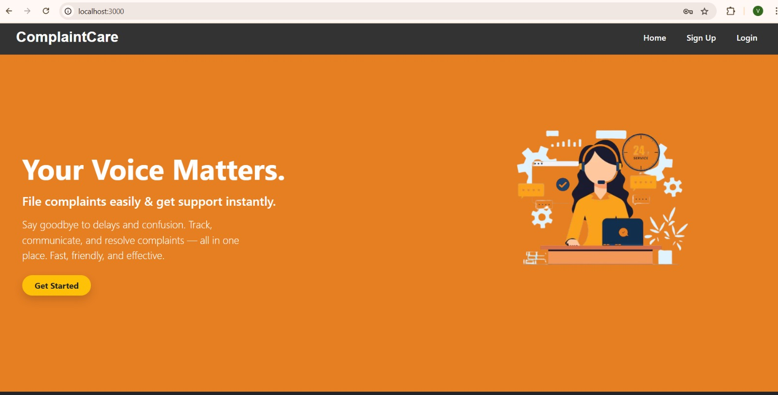

LOGIN PAGE:

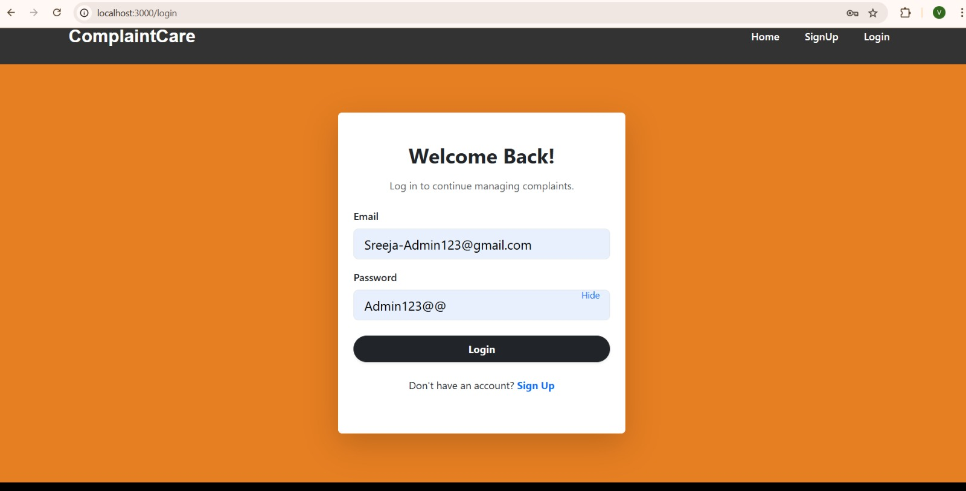

REGISTER PAGE :

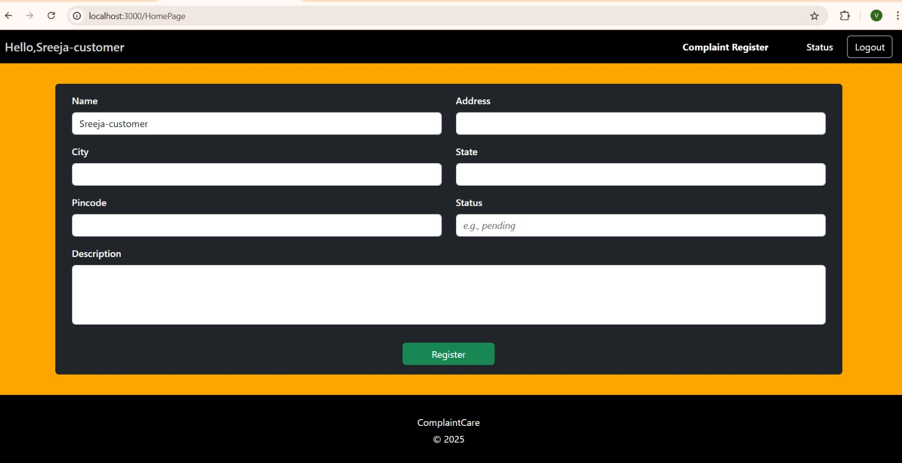

DASHBOARD:

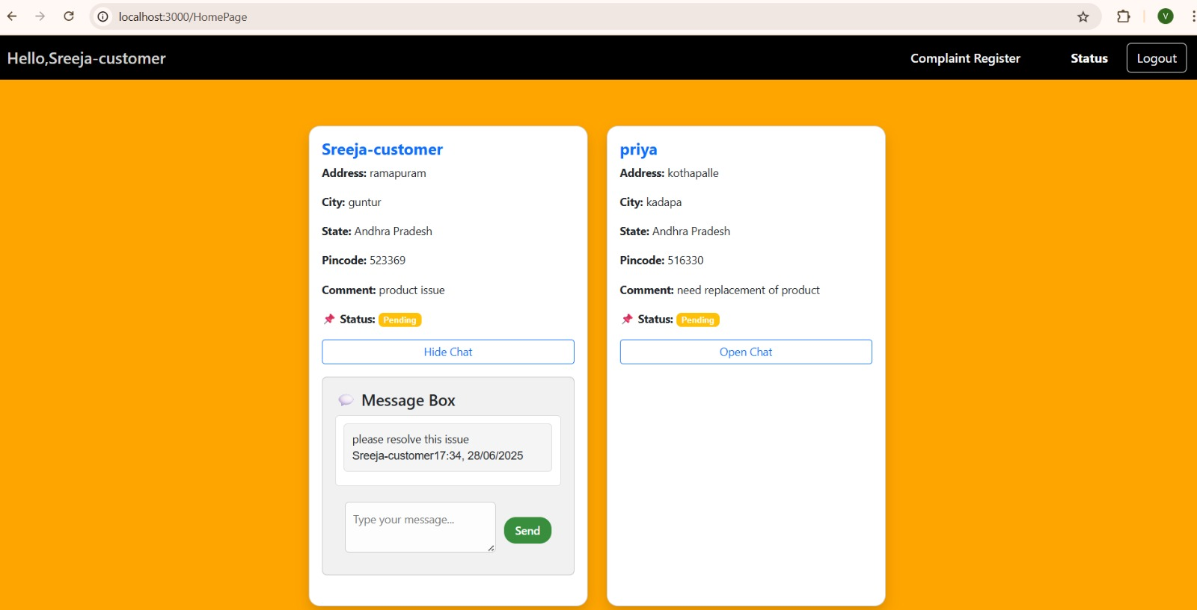

**8. ADVANTAGES & DISADVANTAGES**

**Advantages:**

* Saves time for both citizens and authorities
* Reduces manual paperwork and follow-ups
* Improves user experience through real-time tracking
* Easy to use with a clean and intuitive interface
* Increases transparency and accountability in complaint handling
* Accessible from anywhere (web & mobile support)

**Disadvantages:**

* Requires a stable internet connection to use the platform
* Initial setup and deployment may involve some cost
* There may be a learning curve for older or non-tech-savvy users

**9. CONCLUSION**

The **ResolveNow** project successfully delivers a digital solution for public grievance redressal. By leveraging modern web technologies and Agile development practices, the system enhances efficiency, promotes transparency, and improves user satisfaction. It simplifies the complaint process, ensures faster resolution, and builds trust between citizens and authorities through a centralized and user-friendly platform.

**10. FUTURE SCOPE**

* Integration with government portals for automated complaint routing
* AI-based complaint categorization and priority tagging
* Multi-language support for wider accessibility
* Advanced analytics for admin (heatmaps, resolution times, trends)
* Mobile app version for on-the-go access
* Role-based dashboards for citizens, departments, and admins
* Integration with GIS/maps for visual complaint tracking

**11. APPENDIX**

Source Code :

<https://github.com/sreejaalle/Complaint-Registry>